## Programming Project

Team members and Responsibility:

電資三 108820001 羅羽軒: ch2 proj 1, ch3 proj 2

電資三 108820003 林天佑: ch2 proj 1, ch3 proj 2

電資三 108820016 郭梓琳: ch2 proj 1, ch3 proj 1

電資三 108820031 簡上博: ch2 proj 1, ch3 proj 1

### Ch2 Proj1

### 

### Ch3 Proj1

下載GCC：

於cmd內輸入以下指令：

1. sudo apt update （更新軟體包）

2. sudo apt install build-essential （安裝build-essential）

3. gcc --version（確認gcc安裝成功）

**execution snapshot**

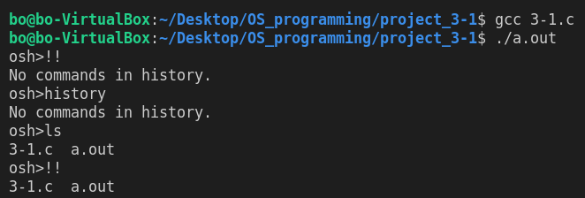

### Ch3 Proj2

For the instruction to execute, please refer to *readme.md* in the *ch3_proj_2* directory.

**execution snapshot**

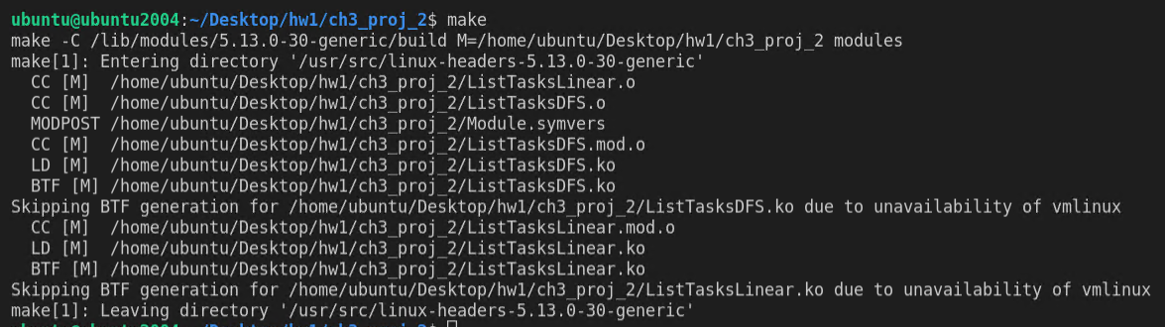

**Part1:**

compare between output of *dmesg* and *ps -el* can find they are almost the same

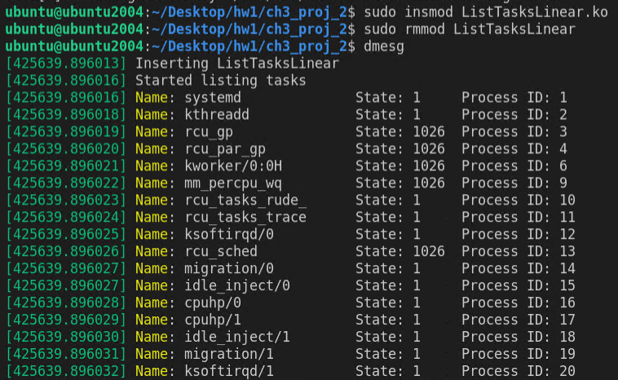







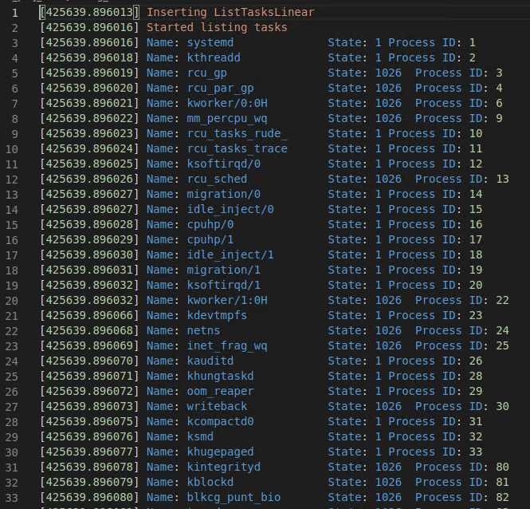

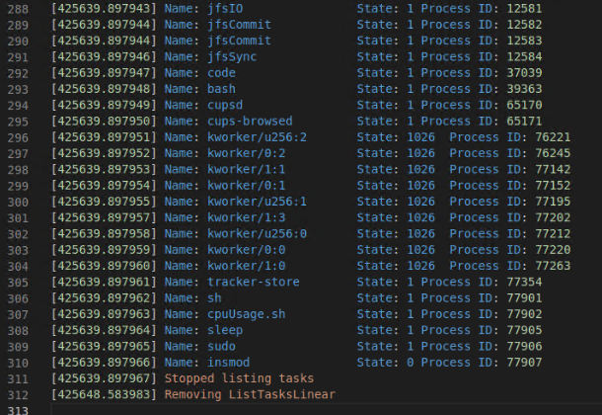

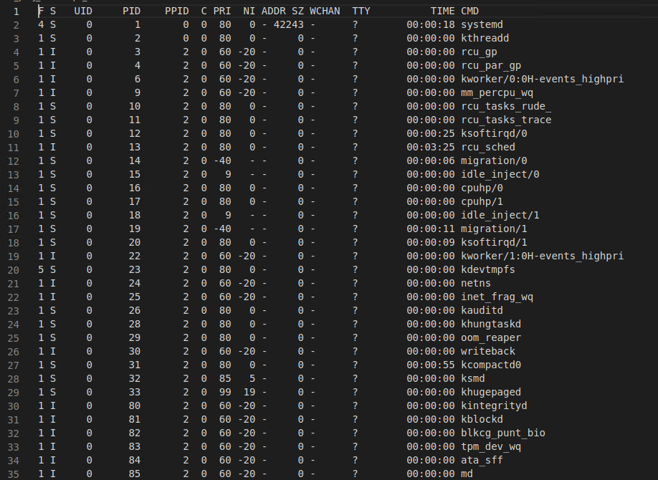

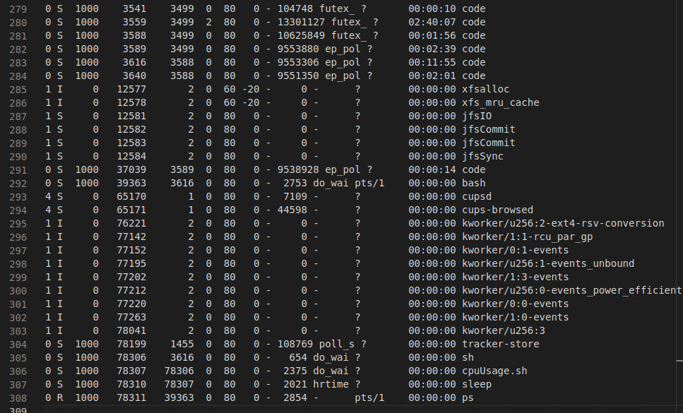

**Part2:**

compare output between *dmesg* and *ps -eLf* can find they are very similar

